

Project Report

SpendWise - Smart Expense Tracker (Android)

Prepared For: CSE-3111 Software Development Project
Prepared By:

Name | ID | Batch
Riduan Aziz | 0752220005101007 | Regular-18th

Submitted to:

Md. Ishtiaq Iqbal
Assistant Professor and Chairman
Department of Computer Science and Engineering
Cox’s Bazar International University
13th January 2026

Chapter 1: Introduction

1.1 Background
With the increasing cost of living, individuals need an efficient way to monitor daily expenses and manage personal finances. Traditional methods such as notebooks, spreadsheets, or mental tracking are time-consuming, inaccurate, and difficult to analyze overtime.
SpendWise is developed to provide a modern, mobile-based solution that allows users to record expenses instantly, categorize spending, analyze trends, and generate reports using a secure cloud backend.

1.2 Problem Statement
Manual expense tracking is inefficient, error-prone, and lacks real-time insights. Users face difficulties in organizing expenses, calculating monthly totals, and understanding category-wise spending patterns. There is a need for a simple, secure, and automated system to manage personal expenses effectively.

1.3 Objectives
- To allow users to add, edit, and delete expenses easily.
- To provide real-time tracking of daily, monthly, and total expenses.
- To analyze expenses category-wise using charts.
- To support offline access with automatic synchronization.
- To enable export of expense reports in CSV and PDF formats.
- To ensure secure, user-specific data storage.

1.4 Scope & Limitations

Scope
- Expense tracking for individual users.
- Firebase-based authentication and data storage.
- Category-wise and monthly expense analysis.
- Report export functionality

Limitations
- Requires internet for authentication and report upload
- Aggregation is primarily client-side
- No built-in budget alerts in the current version

Chapter 2: System Analysis & Requirements

2.1 Existing System
Currently, users track expenses using:
- Manual notebooks
- Excel spreadsheets
- Basic calculator applications
These methods lack automation, real-time analysis, security, and cloud backup.

2.2 Proposed System
SpendWise replaces manual tracking with:
- A mobile-based Android application
- Secure login using Firebase Authentication
- Real-time cloud data storage
- Automatic calculations and analytics
- Offline data persistence

2.3 Functional Requirements
- User Registration and Login
- Add, Edit, Delete Expense
- View Expense List.
- Filter expenses by date, category, and notes.
- View dashboard summary.
- Generate CSV/PDF reports..
- Profile management and password reset

2.4 Non-Functional Requirements
- Security: Firebase Authentication & access rules.
- Performance: Dashboard load < 1 second.
- Reliability: Crash-free usage.
- Usability: Simple and intuitive UI.
- Compatibility: Android API level 26+

2.5 Hardware & Software Requirements

Hardware
- Android smartphone
- Minimum 4GB RAM
- Internet connection

Software
- Android Studio
- Java
- Firebase Realtime Database
- Firebase Authentication
- Firebase Storage

Chapter 3: System Design

3.1 Use Case Diagram

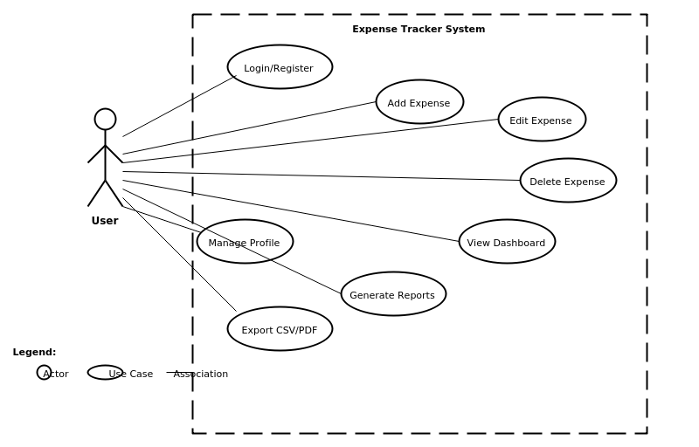

3.2 Activity / Flow Chart
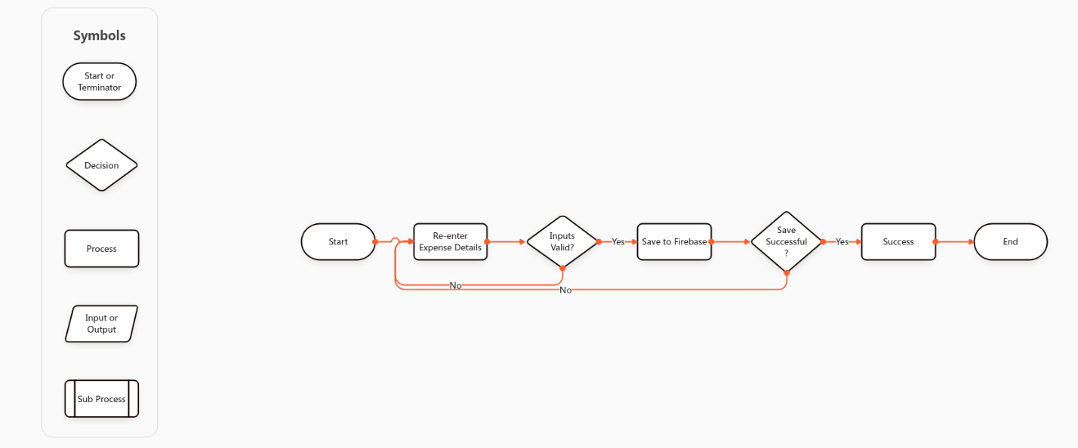

3.3 Application Package Structure
app/
├── manifests/
│ └── AndroidManifest.xml
│
├── java/
│ └── com/
│ └── ra/
│ └── set/
│ ├── activities/
│ │ ├── AddExpenseActivity.java
│ │ ├── DashboardActivity.java
│ │ ├── EditExpenseActivity.java
│ │ ├── ExpensesActivity.java
│ │ ├── ExportActivity.java
│ │ ├── LoginActivity.java
│ │ ├── ProfileActivity.java
│ │ ├── RegisterActivity.java
│ │ └── ReportsActivity.java
│ │
│ ├── adapters/
│ │ ├── CategorySummaryAdapter.java
│ │ └── ExpenseAdapter.java
│ │
│ ├── models/
│ │ ├── CategorySummary.java
│ │ ├── Expense.java
│ │ └── LoginRequest.java
│ │
│ ├── network/
│ │ ├── ApiClient.java
│ │ └── ApiService.java
│ │
│ └── utils/
│ ├── DateUtils.java
│ ├── PasswordUtils.java
│ ├── SessionTimeout.java
│ ├── MainActivity.java
│ └── SETApp.java
│
├── res/
│ ├── drawable/
│ │ ├── bg_avatar.xml
│ │ ├── bg_card.xml
│ │ ├── bg_category.xml
│ │ ├── bg_circle_avatar.xml
│ │ ├── bg_icon.xml
│ │ ├── card_bg.xml
│ │ ├── ic_add.xml
│ │ ├── ic_app.xml
│ │ ├── ic_calendar.xml
│ │ ├── ic_dashboard.xml
│ │ ├── ic_expenses.xml
│ │ ├── ic_exports.xml
│ │ ├── ic_reports.xml
│ │ ├── ic_search.xml
│ │ └── ic_wallet.xml
│ │
│ ├── layout/
│ │ ├── activity_add_expense.xml
│ │ ├── activity_dashboard.xml
│ │ ├── activity_edit_expense.xml
│ │ ├── activity_expenses.xml
│ │ ├── activity_export.xml
│ │ ├── activity_login.xml
│ │ ├── activity_profile.xml
│ │ ├── activity_register.xml
│ │ ├── activity_reports.xml
│ │ ├── dialog_change_password.xml
│ │ ├── dialog_edit_profile.xml
│ │ ├── dialog_reset_password_full.xml
│ │ ├── bottom_nav.xml
│ │ ├── top_bar_card.xml
│ │ ├── layout_piechart_breakdown.xml
│ │ └── item_category_summary.xml
│ │
│ ├── menu/
│ │ └── menu_profile.xml
│ │
│ ├── values/
│ │ ├── arrays.xml
│ │ ├── colors.xml
│ │ ├── ids.xml
│ │ ├── strings.xml
│ │ └── themes.xml
│ │
│ └── xml/
│ ├── backup_rules.xml
│ └── data_extraction_rules.xml
│
├── java (generated)/
├── res (generated)/
└── Gradle Scripts/
├── build.gradle.kts (Project)
├── build.gradle.kts (Module: app)
├── gradle.properties
├── gradle-wrapper.properties
├── local.properties
├── settings.gradle.kts
├── libs.versions.toml
└── proguard-rules.pro

3.4 E-R Diagram
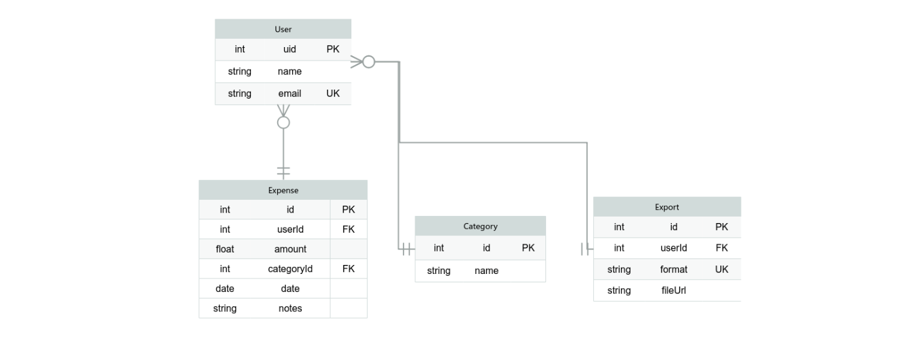

3.5 Database Schema (Firebase Realtime Database)
{
"users": {
"<authUid_1>": {
"profile": {
"authUid": "ND8QX0trglZjMHmVeaZoQzwXPdt1",
"uid": "uid_1001",
"email": "ra@ext.org",
"name": "Riduan",
"createdAt": 1768152531572
},
"expenses": {
"-OimXs--0ix1yqm3O8by": {
"id": "-OimXs--0ix1yqm3O8by",
"amount": 50,
"category": "Other",
"note": "N",
"date": "2026-01-12",
"timestamp": 1768154400000
},
"summaries": {
"global": {
"total": 5690,
"byCategory": {
"Food": 2300,
"Transport": 800,
"Utilities": 600,
"Other": 1990
},
"byMonth": {
"2026-01": {
"total": 1200,
"Food": 500,
"Other": 700
},
"2025-12": {
"total": 1940,
"Transport": 800,
"Utilities": 600,
"Other": 540
}
}
}
}
},
},
"appSettings": {
"categories": {
"Food": true,
"Transport": true,
"Utilities": true,
"Entertainment": true,
"Other": true
},
"currency": "USD",
"defaultView": "dashboard"
},
"meta": {
"lastUpdated": 1768200000000,
"version": "1.0.0"
}
}

Root Structure
Root
│
├── users
│ ├── {authUid_1}
│ │ ├── profile
│ │ ├── expenses
│ │ ├── categories
│ │ └── summaries
│ ├── {authUid_2}
│ │ ├── profile
│ │ ├── expenses
│ │ ├── categories
│ │ └── summaries
│ └── ...
│
├── appSettings
│ ├── categories
│ ├── currency
│ └── defaultView
│
└── meta
├── lastUpdated
└── version

Expense Object
- userId
- expenseId
- amount
- categoryName
- notes
- date
- timestamp
- createdAt

Aggregates (Derived Data)
- All Time totals
- Daily totals
- Monthly totals
- Category totals

3.6 System Architecture
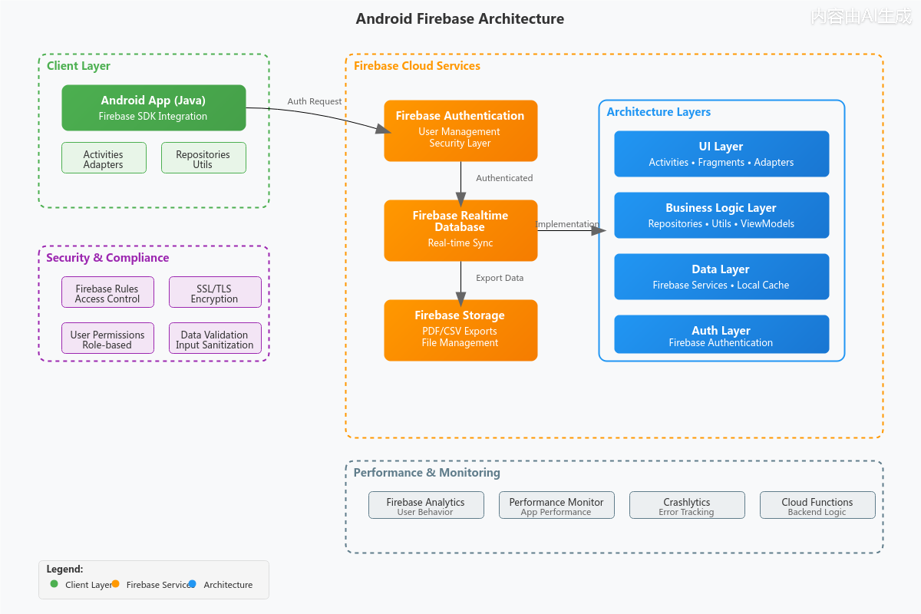

Chapter 4: Implementation

4.1 Technology Stack Description
- Frontend: Android (Java)
- Backend: Firebase Realtime Database
- Authentication: Firebase Authentication
- Storage: Firebase Storage

4.2 UI Screenshots (Captions)

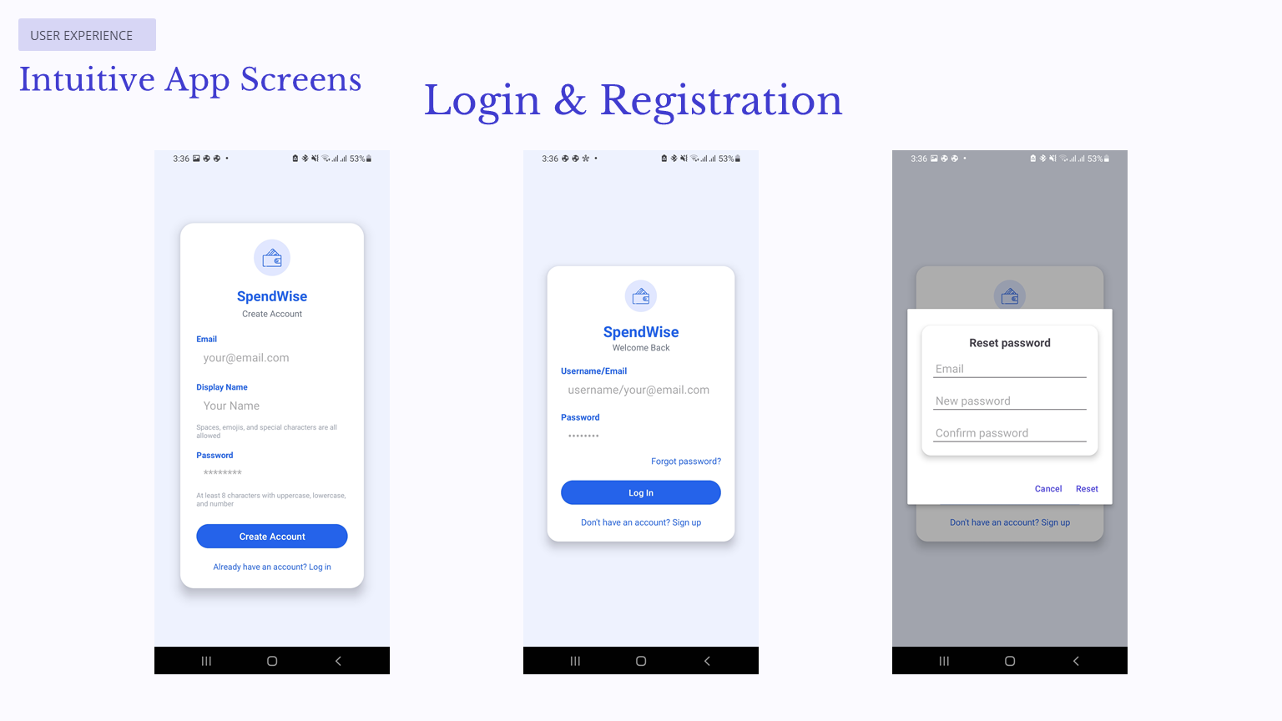

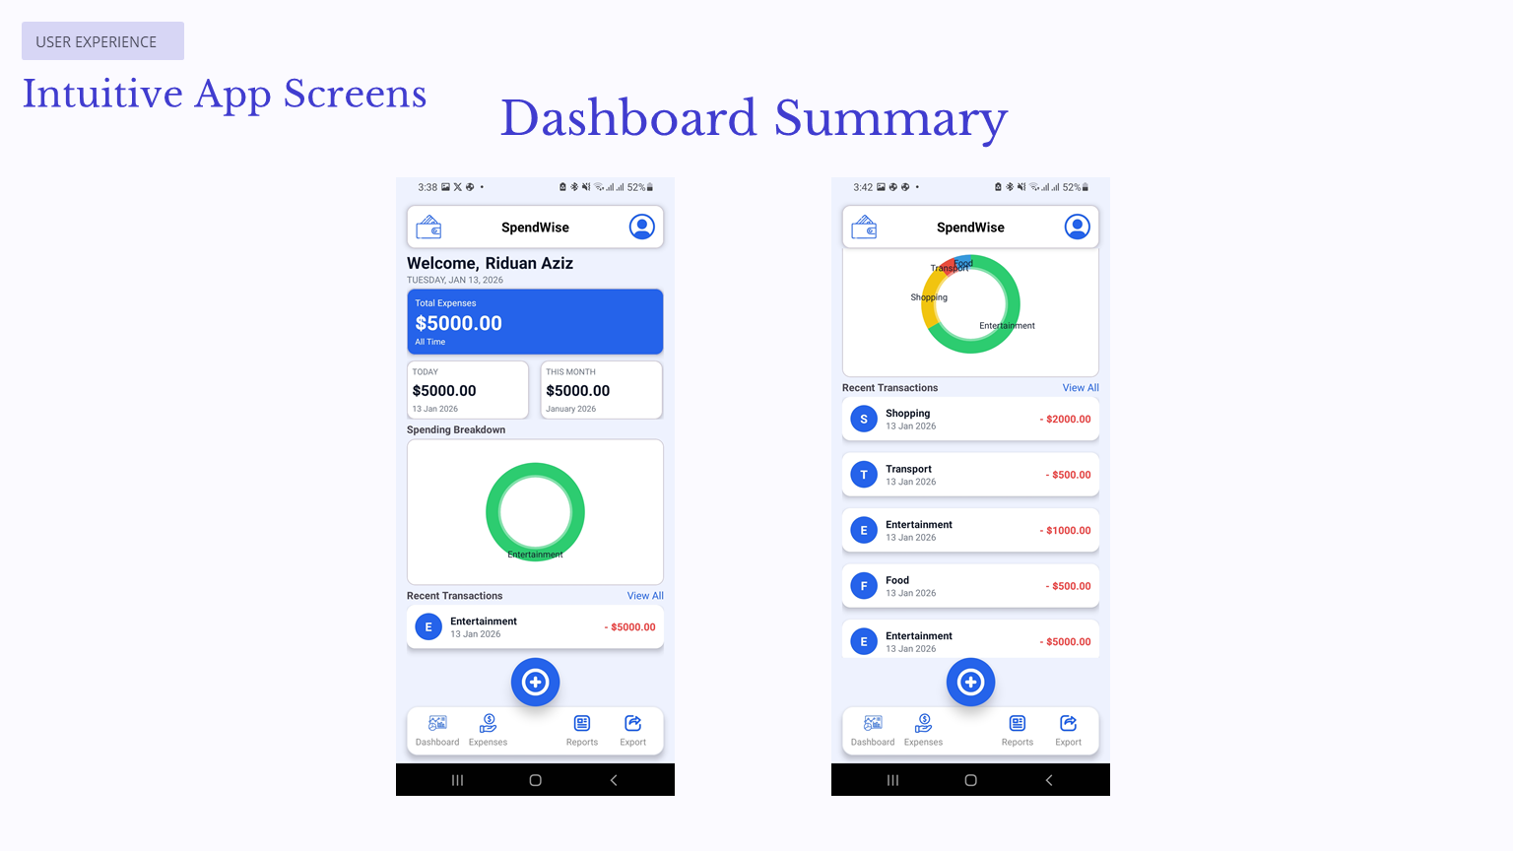

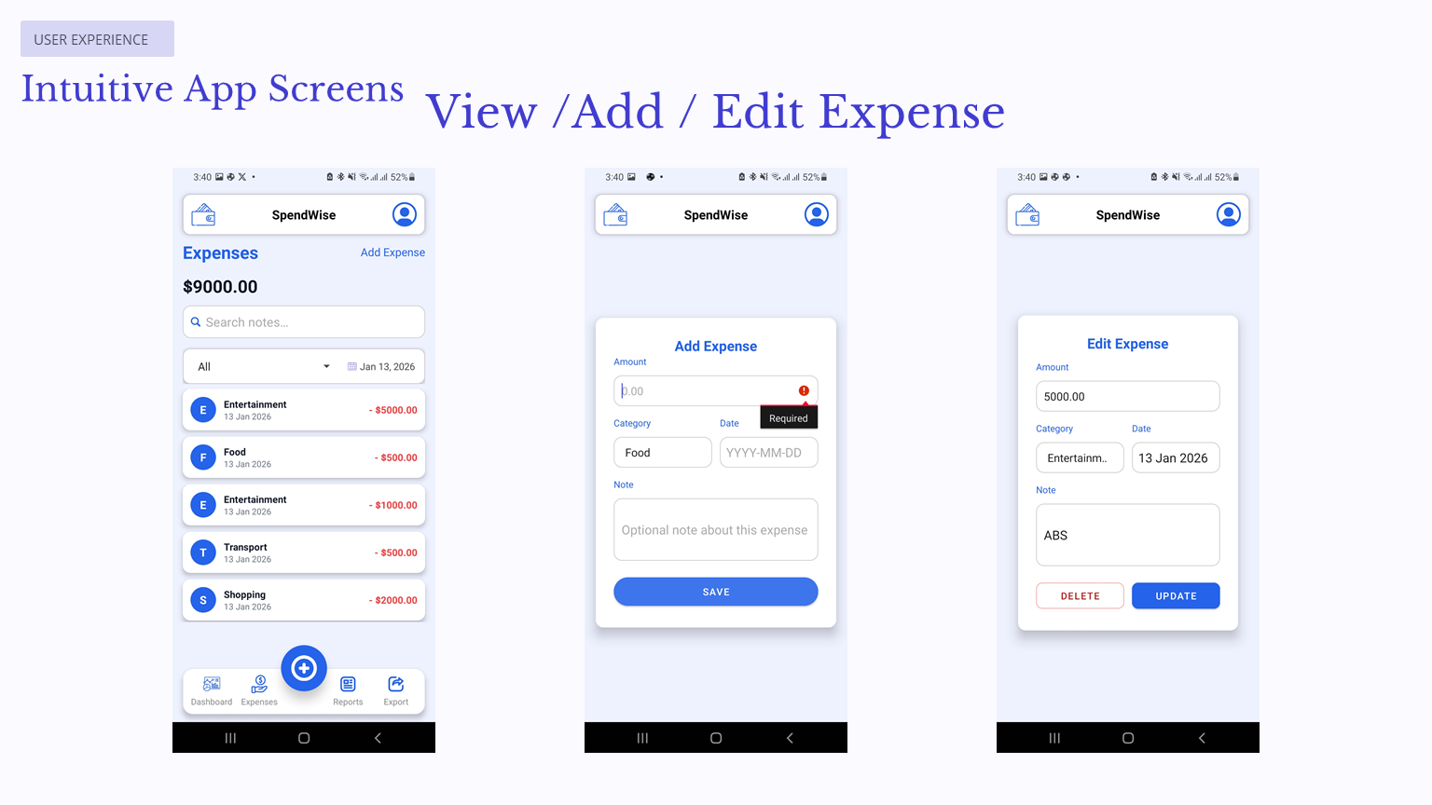

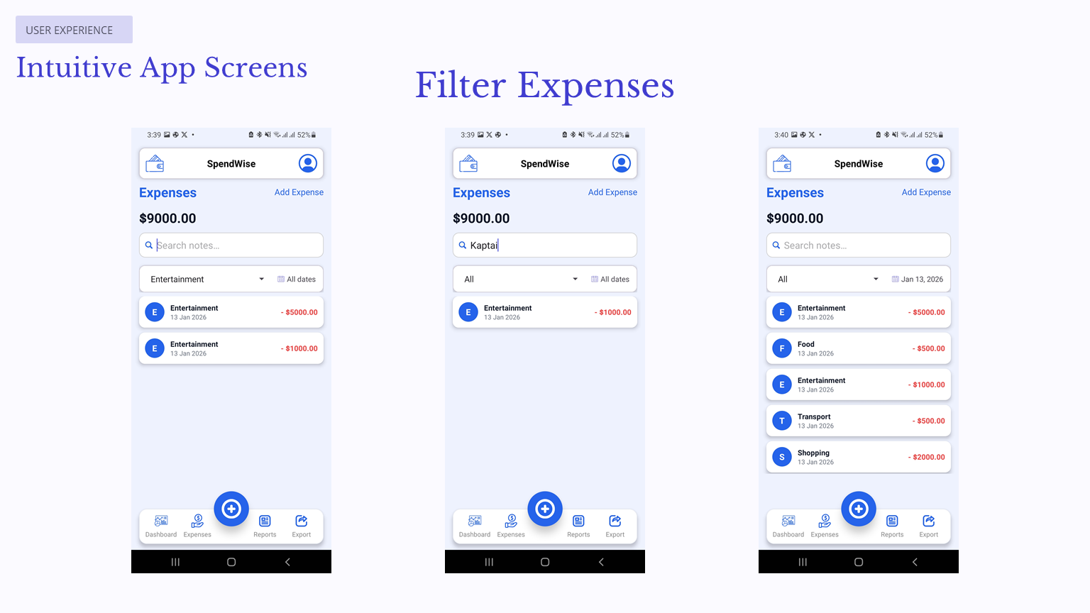

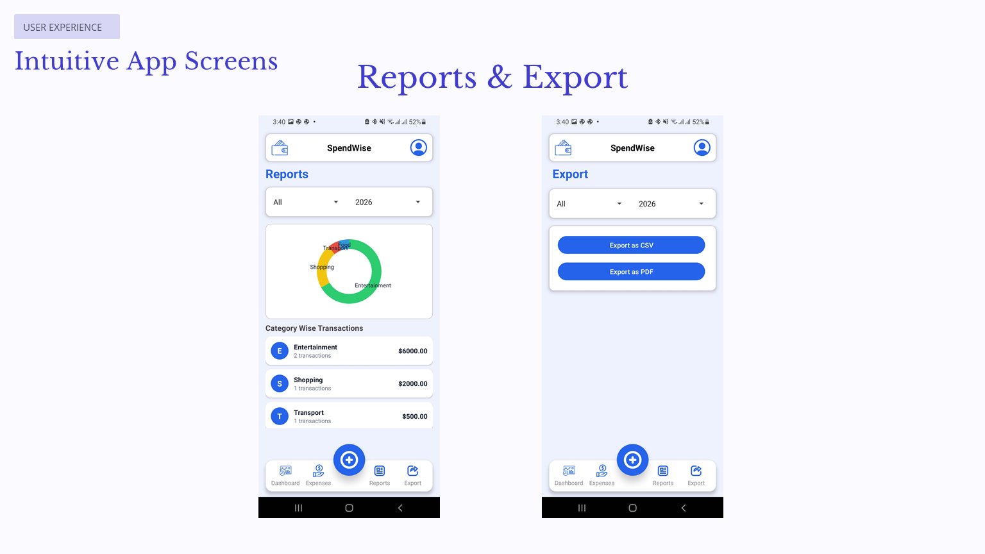

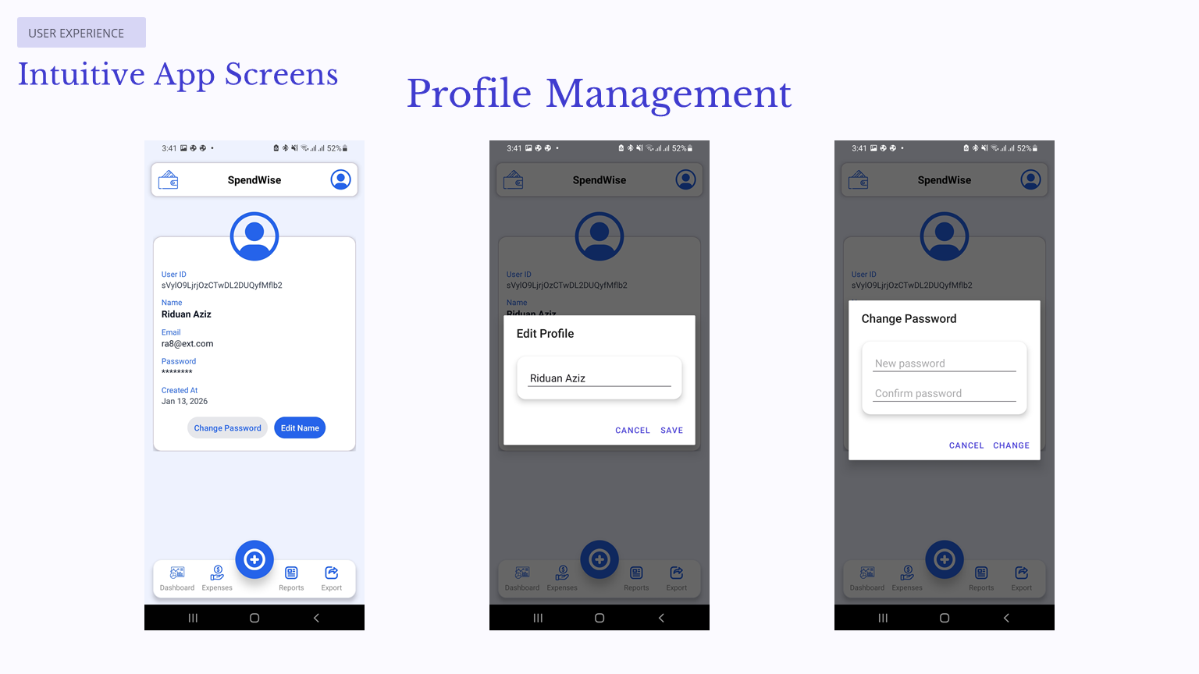

4.3 Key Code Snippets

4.3.1 Activity Setup
public class ExpensesActivity extends AppCompatActivity {
private RecyclerView recyclerView;
private ExpenseAdapter adapter;
private final List<Expense> expenseList = new ArrayList<>();
private final List<Expense> allExpenses = new ArrayList<>();

@Override
protected void onCreate(Bundle savedInstanceState) {
super.onCreate(savedInstanceState);
setContentView(R.layout.activity_expenses);

initViews();
setupRecycler();
setupFirebaseListener();
setupFilters();
setupBottomNavigation();
}
}

4.3.2 Firebase Realtime Database Listener
private void setupFirebaseListener() {
String uid = FirebaseAuth.getInstance().getCurrentUser().getUid();
DatabaseReference ref = FirebaseDatabase.getInstance()
.getReference("users").child(uid).child("expenses");

expensesQuery = ref.orderByChild("timestamp");

expensesListener = new ValueEventListener() {
@Override
public void onDataChange(@NonNull DataSnapshot snapshot) {
allExpenses.clear();
for (DataSnapshot ds : snapshot.getChildren()) {
Expense e = ds.getValue(Expense.class);
if (e != null) {
e.setId(ds.getKey());
allExpenses.add(e);
}
}
applyFiltersLocally();
}
@Override
public void onCancelled(@NonNull DatabaseError error) {}
};
expensesQuery.addValueEventListener(expensesListener);
}

4.3.3 RecyclerView Setup
private void setupRecycler() {
recyclerView.setLayoutManager(new LinearLayoutManager(this));
adapter = new ExpenseAdapter(this, expenseList);

adapter.setOnItemClickListener(expense -> {
Intent i = new Intent(this, EditExpenseActivity.class);
i.putExtra(EditExpenseActivity.EXTRA_EXPENSE_ID, expense.getId());
startActivity(i);
});

recyclerView.setAdapter(adapter);
}

4.3.4 Search, Category, and Date Filters
private void setupFilters() {
etSearchBox.addTextChangedListener(new TextWatcher() {
@Override public void afterTextChanged(Editable s) {
currentSearch = s.toString().trim();
applyFiltersLocally();
}
});

spCategoryFilter.setOnItemSelectedListener(new AdapterView.OnItemSelectedListener() {
@Override
public void onItemSelected(AdapterView<?> parent, View view, int pos, long id) {
currentCategory = parent.getItemAtPosition(pos).toString();
applyFiltersLocally();
}
@Override public void onNothingSelected(AdapterView<?> parent) {}
});

tvDateFilterView.setOnClickListener(v -> showDatePicker());
}

Chapter 5: Testing

5.1 Test Cases
Test Case ID | Input Data | Expected Result | Actual Result | Status
TC01 | Valid Login | Login Success | Login Success | Pass
TC02 | Add Expense | Expense Saved | Expense Saved | Pass
TC03 | Edit Expense | Data Updated | Data Updated | Pass
TC04 | Export CSV | File Generated | File Generated | Pass
TC05 | Invalid Login | Error Message | Error Message | Pass

Chapter 6: Conclusion & Future Scope

6.1 Conclusion
SpendWise is a secure, efficient, and user-friendly expense tracking application developed using Java and Firebase. It simplifies expense management, provides valuable insights, and supports offline usage, making it suitable for daily personal finance tracking.

6.2 Future Scope
- Budget limit alerts
- Yearly analytics
- Multi-currency support
- Cloud Functions for automation
- Backup and restore feature

